Hands on-1 Environment Setup, Project Structure & First Component

Task 1: Scaffold and Explore the Angular Project
Steps:
1. Run ng new student-course-portal --routing --style=css. Accept defaults for all prompts.
2. Open the project in VS Code. For each of the following files, write a one-line comment in a notes.txt file explaining its purpose: angular.json, tsconfig.json, tsconfig.app.json, package.json, src/main.ts, src/app/app.module.ts (or app.config.ts in standalone mode), src/app/app.component.ts, src/index.html.
3. Run ng serve and open http://localhost:4200. Verify the default Angular welcome page loads.
4. Run ng build and inspect the dist/ folder. Note the generated files — identify which file contains the compiled application code.
5. In angular.json, locate the budgets configuration under architect > build > configurations > production. Note the maximumWarning and maximumError thresholds — document what these control.

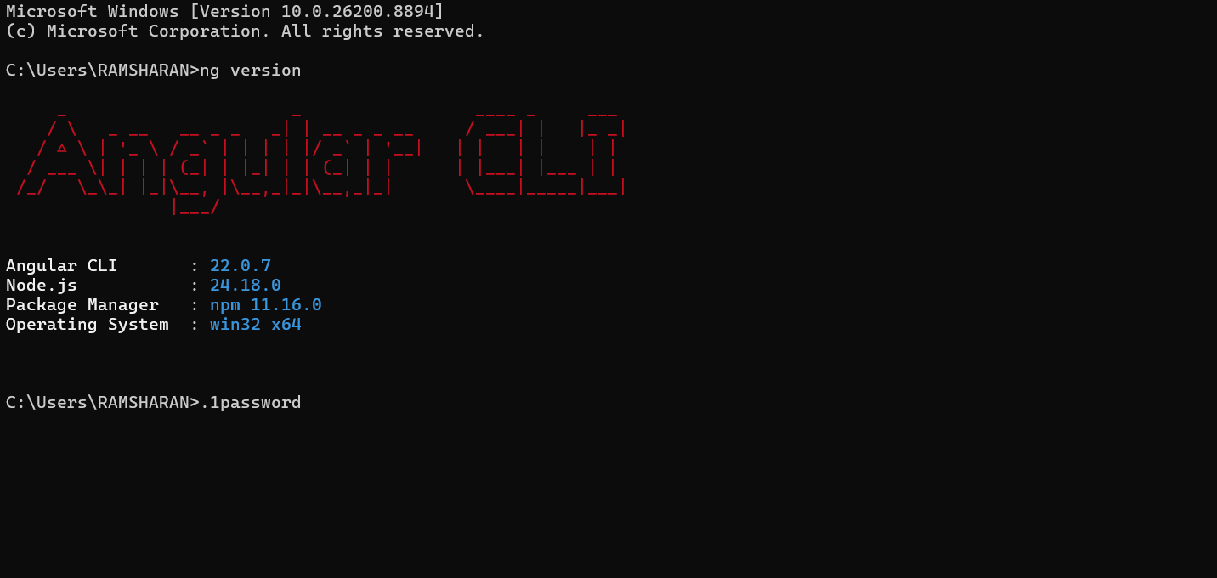
Component Implementation
Header Component Template (src/app/components/header/header.html)
<nav class="navbar">
<h2>Student Course Portal</h2>
<ul class="nav-links">
<li><a href="#">Home</a></li>
<li><a href="#">Courses</a></li>
<li><a href="#">Profile</a></li>
</ul>
</nav>
Home Component Template (src/app/pages/home/home.html)

<section class="welcome-section">
<h1>Welcome to the Student Course Portal</h1>
<p>Manage your enrolled courses, view your academic progress, and update your profile all in one place.</p>

<div class="stats-row">
<div class="stat-card">
<h3>Courses Available</h3>
<p>12</p>
</div>
<div class="stat-card">
<h3>Enrolled</h3>
<p>3</p>
</div>
<div class="stat-card">
<h3>GPA</h3>
<p>3.8</p>
</div>
</div>
</section>
Root Component Assembly
src/app/app.ts:
import { Component } from '@angular/core';
import { RouterOutlet } from '@angular/router';
import { HeaderComponent } from './components/header/header';
import { HomeComponent } from './pages/home/home';

@Component({
selector: 'app-root',
standalone: true,
imports: [RouterOutlet, HeaderComponent, HomeComponent],
templateUrl: './app.html',
styleUrl: './app.css'
})
export class AppComponent {
title = 'student-course-portal';
}
src/app/app.html:
<app-header></app-header>
<main class="content-container">
<app-home></app-home>
<router-outlet></router-outlet>
</main>
